Weekly Booking Form

-------------------------------------

-------------------------------------

After School Club

Stripes

This form must be handed in to Stripes staff, the school office or e-mailed to stripes@twogates.staffs.sch.uk with the ParentPay payment reference quoted by Wednesday of the week before care is required.

***No booking forms will be accepted without payment in full. To enable the correct staff***

***ratios to be allocated the booking MUST be made by Wednesday of the week before***

***childcare is required. Late bookings will not be accepted.***

Name of child……………………………………. Week commencing Monday …./…../…..

|  |  |  |
| --- | --- | --- |
| **Child/Children’s Name/s: Childcare Required Week Commencing:** | | |
| **Day** | **Session Childcare Required**  ***(please tick)*** | **Cost per session**  **£9.50 per child**  **or £8.50 per child if more than one**  **sibling attending the same session** |
| Monday |  |  |
| Tuesday |  |  |
| Wednesday |  |  |
| Thursday |  |  |
| Friday |  |  |
| Total Weekly Cost: | £ |  |
| ParentPay Payment made Amount: £ Date: | | |

Please

• Tick the sessions you require

• Add up weekly cost and complete the total amount MCj02904960000[1]

• Specify the ParentPay reference & date payment made

• Return to school by Wednesday of the week before care is required

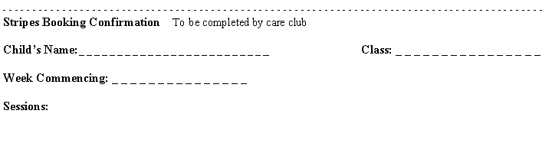Signed: …………………………………………………………. Parent/Carer



- - - - - - - - - - - - - - - - - - - - - - - - - - - - - - - - - - - - - - - - - - - - - - - - - - - - - - - - - - - - - - - - - - - - - - - - - - - - - - - - - - - - - - - - - - -

**Stripes Booking Confirmation** To be completed by care club

**Child’s Name:­­**_ _ _ _ _ _ _ _ _ _ _ _ _ _ _ _ _ _ _ _ _ _ _ _ **_ Class: _ _ _ _ _ _ _ _ _ _ _ _ _ _ _ _**

**Week Commencing: _ _ _ _ _ _ _ _ _ _ _ _ _ _ _**

**Sessions:**

Please

• Tick the sessions you require

• Add up weekly cost and complete the total amount

• Specify the ParentPay reference & date payment made

• Return to school by Wednesday of the week before care is required

Signed: …………………………………………………………. Parent/Carer

Please

• Tick the sessions you require

• Add up weekly cost and complete the total amount

• Specify the ParentPay reference & date payment made

• Return to school by Wednesday of the week before care is required

Signed: …………………………………………………………. Parent/Carer

- - - - - - - - - - - - - - - - - - - - - - - - - - - - - - - - - - - - - - - - - - - - - - - - - - - - - - - - - - - - - - - - - - - - - - - - - - - - - - - - - - - - - - - - - - -

**Stripes Booking Confirmation** To be completed by care club

**Child’s Name:­­**_ _ _ _ _ _ _ _ _ _ _ _ _ _ _ _ _ _ _ _ _ _ _ _ **_ Class: _ _ _ _ _ _ _ _ _ _ _ _ _ _ _ _**

**Week Commencing: _ _ _ _ _ _ _ _ _ _ _ _ _ _ _**

**Sessions:**